Farmer Friend
It is a mobile application for farmers to acknowledge and understand how to use , where to use a product like pesticide, fertilizer and a tool and it let a farmer know about the policies that government is provide to the farmers
Step By Step Process Of Application
1 Sign In Page
First page after opening the app in mobile that is sign in page
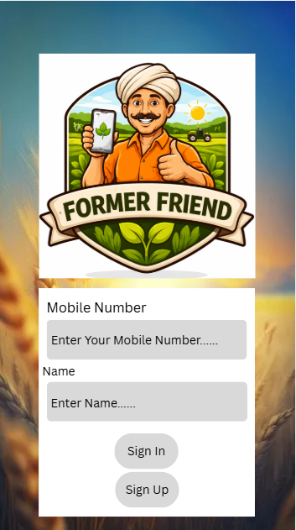
After entering the mobile number and name of the user , then user clicks on the sign in option
if the mobile number and user name should be checked in the user data in cloud which is already stored in cloud , if the data of user is found then sign in and a massage “sign in successfully” will pop up on top right corner in green color, else sign up option will pop up
and a “user not found” massage will pop up at top right corner in red color
User need to enter register mobile number to sign in the application

If the user want to sign up ,then clicks on the sign up option then the next page will gets open
User also need to enter his registered name for sign in

1.1 Sign Up Page
After choosing the sign up option then this page get open
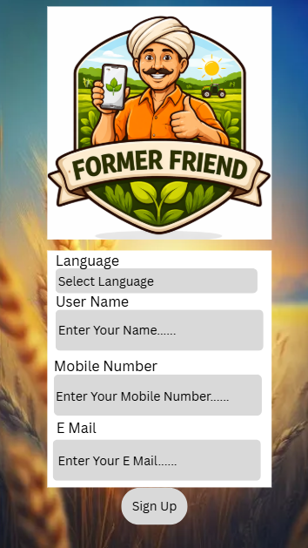
User need to select which language they preferred
User enter their E Mail ID is optional
User should enter their mobile number
User should enter their name
2 Home Page
After enter the above data user clicks on the sign up button then the data of the user will stored in cloud for the further use,
a massage “successfully registered” pops up at top right corner of the screen in green color
and a text massage sent to the register mobile number and e mail as they registered
if the data is already there in the stored user data then a massage “user already existed “ on top right corner in red color
By default user will get pre selected language.
if user want change the language temporarily they can change language by click change language option, when they clicks on the change language option they will find multiple option they can choose what language they comfortable, after change in page the app language will change by default
After successfully sign in/sign up user will find home page
It is a user profile option
when user clicks on this option
user will get their data
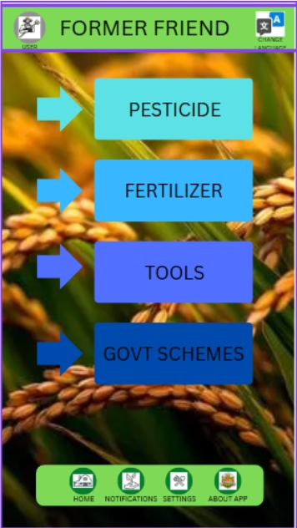
If user clicks on the pesticide option then the pesticide page get open
If user clicks on the fertilizer option then the fertilizer page get open
If user clicks on the tools option then the tools page get open
If user clicks on the govt schemes option then the govt schemes page get open
Irrespect to the present page, when the user click on the about app option then the about app page will get open
Irrespect to the present page, when the user click on the settings option then the settings page will get open
Irrespect to the present page, when the user click on the notification option then the notification page will get open
When the user click on he home option, app should return to the home page irrespect to present page

2.1 Profile Page
when the user click on the profile option, they will get open profile page

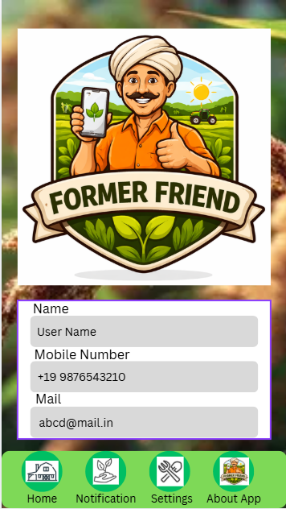
User will find their E Mail ID here

User will find their name here
User will find their mobile number here

2.2 Notifications Page
when user click on the notification option then notification page get open

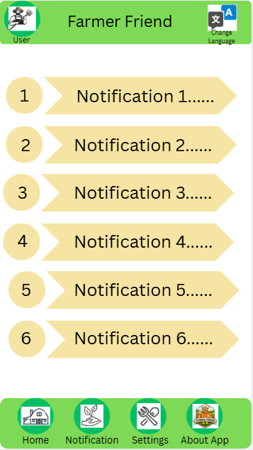
This are the notifications that user receive.
this are the notification regarding the govt schemes.
if user click on any notification, then central policy page or state policy page will get open, with out searching the policy the details of the policy will user get

2.3 Settings Page
when user click on the settings option then settings page get open

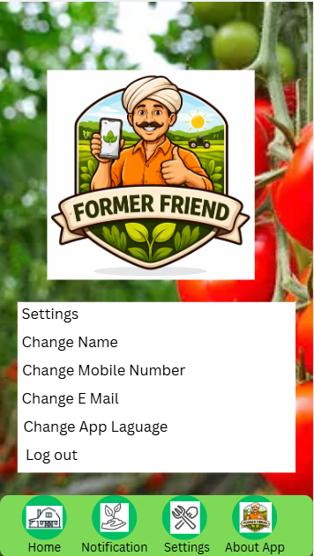
If user want to change user name they can change by click on change name option.
If user want log out from the current account, they can log out by click on the log out option
by default log in page will return
If user want to change the app language then they can change by click on the change app language option
If user want to change E Mail they can change by click on change E Mail option
If user want to change mobile number they can change by click on change mobile number option

2.4 About App Page
when the user clicks on the about app then the about app page will open

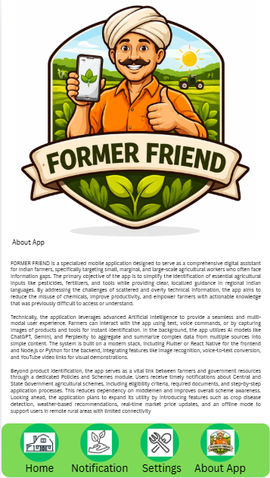
When the user click on the about app then the about app page will open their user can find detailed description about app .
purpose

3 Pesticide Page
when the user click on the pesticide option then the page will open

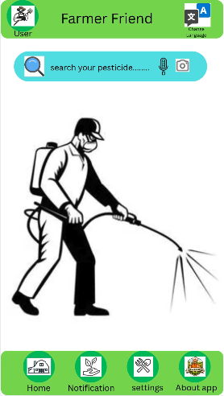
If the user search other than pesticide, a text massage will appears like ” searched item is not pesticide, try again”
If user want search about pesticide by a text
then , user clicks on the search your pesticide to search about it
If user want search about pesticide by a voice
then , user clicks on the mic icon to access mic
If user want search about pesticide by a image
then , user clicks on the camera icon to access camera

3.1 Pesticide searched Page
After search about the pesticide then the pesticide searched page will open

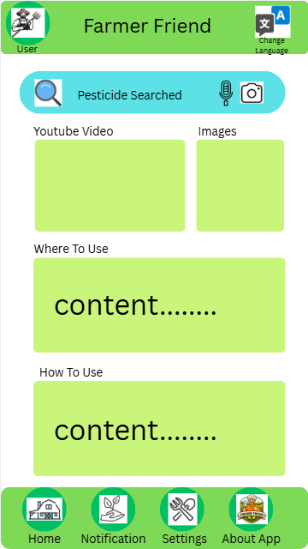
At here a text for about the pesticide like how to use ,where to use, when to use in text form in a simple language

This box has a youtube video about the pesticide like how to use ,where to use, when to use
This box had the images of the pesticide which uploaded in the internet

4 Fertilizer Page
When the user want to know about the fertilizer the clicks on the fertilizer tab then this page will open

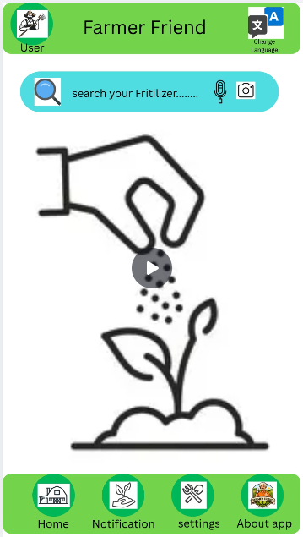
If the user search other than fertilizer, a text massage will appears like ” searched item is not fertilizer, try again”
If user want search about fertilizer by a text
then , user clicks on the search your fertilizer to search about it
If user want search about fertilizer by a voice
then , user clicks on the mic icon to access mic
If user want search about fertilizer by a image
then , user clicks on the camera icon to access camera
4.1 Fertilizer Searched Page
After searching about the fertilizer by any one option like image, voice, or text the this page will open

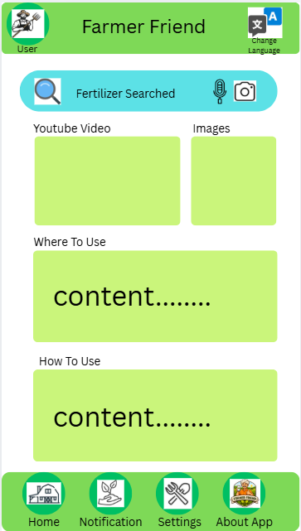
At here a text for about the fertilizer like how to use ,where to use, when to use in text form in a simple language
v
This box has a youtube video about the fertilizer like how to use ,where to use, when to use
This box had the images of the fertilizer which uploaded in the internet

5 Tools Page
When the user want know about the tool then they click on the tool section then this page will open

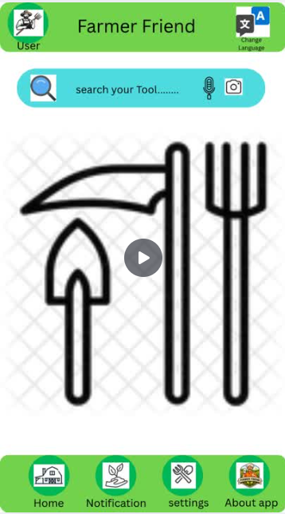
If the user search other than tool, a text massage will appears like ” searched item is not tool, try again”
If user want search about tool by a text
then , user clicks on the search your tool e to search about it
If user want search about tool by a voice
then , user clicks on the mic icon to access mic
If user want search about tool by a image
then , user clicks on the camera icon to access camera
5.1 Tools Searched Page
After search about the tool this page will open

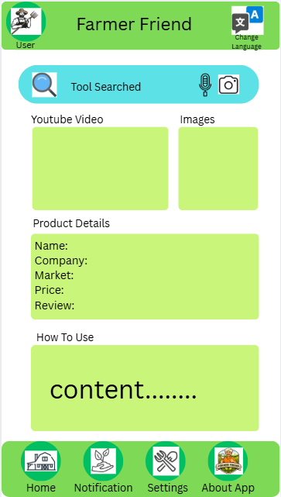
At here a text for about the tool like how to use ,where to use, when to use in text form in a simple language
v
This box contains the about the tool like name , company, market, price of the tool range and review and rating of the tool in varies platform like google, internet, india mart
This box had the images of the tool which uploaded in the internet
This box has a youtube video about the fertilizer like how to use ,where to use, when to use

6 Govt Schemes Page
If user what to know about the govt schemes and policies the they click on the govt schemes
Then this page will open

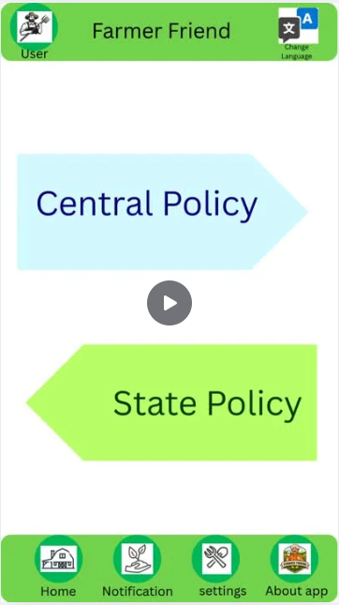
If user want know about the state govt policies then they click on the state policy option
If user want know about the central govt policies then they click on the central policy option

6.1 Central Policies Page
after choosing the central policy option then this page will open

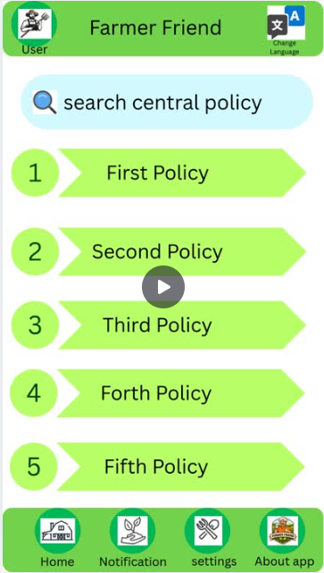
In this page there are multiple central schemes and policies user can choose any one of the option

6.1.1 Central Policies Page
After selecting any one of the policies then this page will open
this page consist about the policy or scheme in detail

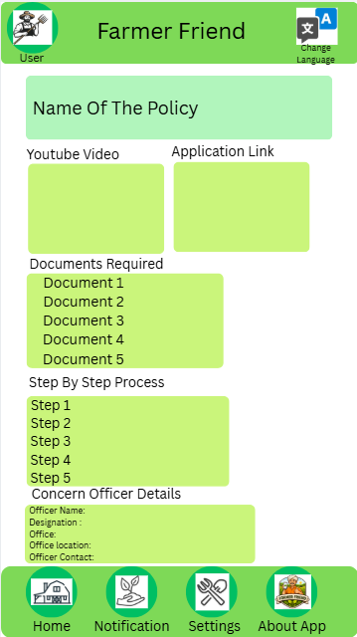
Here the name of the policy
Here if user require to take guidance or need to talk to concern officer the this section have name, designation , office contact and office location
In this section a step by step process for the application in local simple language
This gives that what document required for that policy or scheme and also it give from where the document will they get
Here the user have the application link to apply for the policy or scheme
This box has a youtube video about the policy like how to apply, what documents required and stating and closing date of the application

6.2 State Policies Page
if user choose the state policy then this page will open

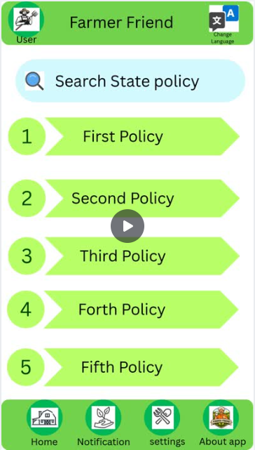
In this page there are multiple state schemes and policies user can choose any one of the option

6.2.1 State Policies Page
After selecting any one of the policies then this page will open
this page consist about the policy or scheme in detail

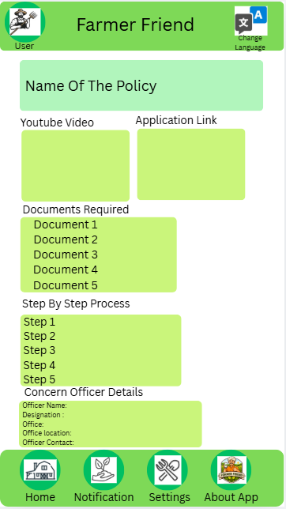
This box has a youtube video about the policy like how to apply, what documents required and stating and closing date of the application
Here if user require to take guidance or need to talk to concern officer the this section have name, designation , office contact and office location
In this section a step by step process for the application in local simple language
This gives that what document required for that policy or scheme and also it give from where the document will they get
Here the user have the application link to apply for the policy or scheme
Here the name of the policy

